**Notes for practical implementation in Ansys Fluent**

**Part 3 – post-processing**

1. **Plot 2D contours of velocity and pressure**
2. **Plot 2D vector plots of velocity**
3. **Defining lines and planes on which to plot**
4. **Plot 3D iso-surfaces**
5. **Using the graphical scene definition and lights**

# Hurdle 4: How to inspect the data

Note for manipulating the view of the object in the display of graphics, use left mouse to rotate, centre mouse to zoom or zoom out on a window, and right mouse to probe.

Before you begin you may find it helpful to change to change to Tab Graphics-Console view – it makes the display larger and you can then use the tab at the bottom of the screen to switch between Console and Graphics to see the software text feed or the graphics window(s). Sometimes the Console/Graphics tabs can disappear from the bottom of the screen during calculation. If this happens get it back again by clicking the restore window button (double square on title bar at top of the GUI) and then click again on the restore window button (now a single square).

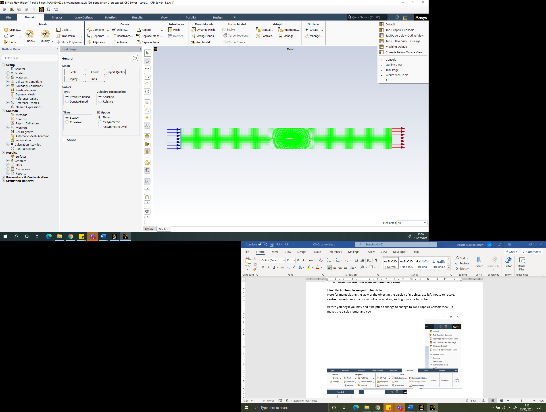

Figure panel for switching the GUI window arrangement, accessed by clicking on the menu item seen at the top right next to Ansys logo.

At this point the default orientation might be irritating if you created your model in other than x-directon in the flow direction. You can fix that by choosing Transform from Domain in the overhead menu and Rotate by 90° to make the duct horizontal.

# Step 1: Mesh display options

In the Results menu (Figure 2) select Mesh. In the mesh panel (Figure 2) select the elements of the mesh you wish to show in the plots.

Unselect the ‘interior-ff-1_surface’ if you wish to plot the geometry without the mesh, check the Faces box if you wish to see the outline made bold; checking the Nodes box will diplay node positions with a circle and if you zoom in, you will see that Fluent considers the nodes at the intersection of cell faces.

Selecting edges will show, depending on edge type selected, either all cell edges, or features or outlines of the geometry. Selecting faces highlights in some ways the faces of the cells – it can be useful in 3D models display.

# Step 2: 2D contour plots

Select Results either from top menu or from the side. Select Contours, New, and select contours of a variable – start with pressure. Unselect all surfaces (this is important to improve the plot; try by first selecting interior-fff_surface and compare; it’s awful) and plot the ‘static pressure’ which is the pressure registered by the static pressure tapping on a Pitot-Static tube.

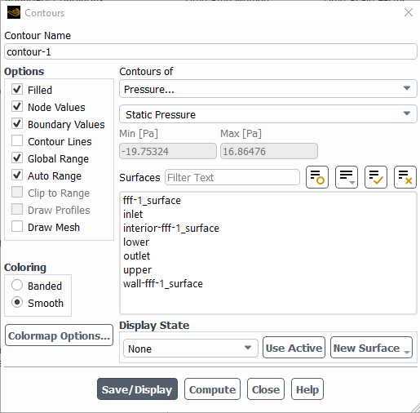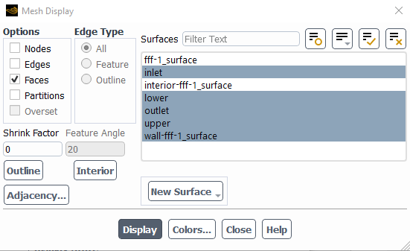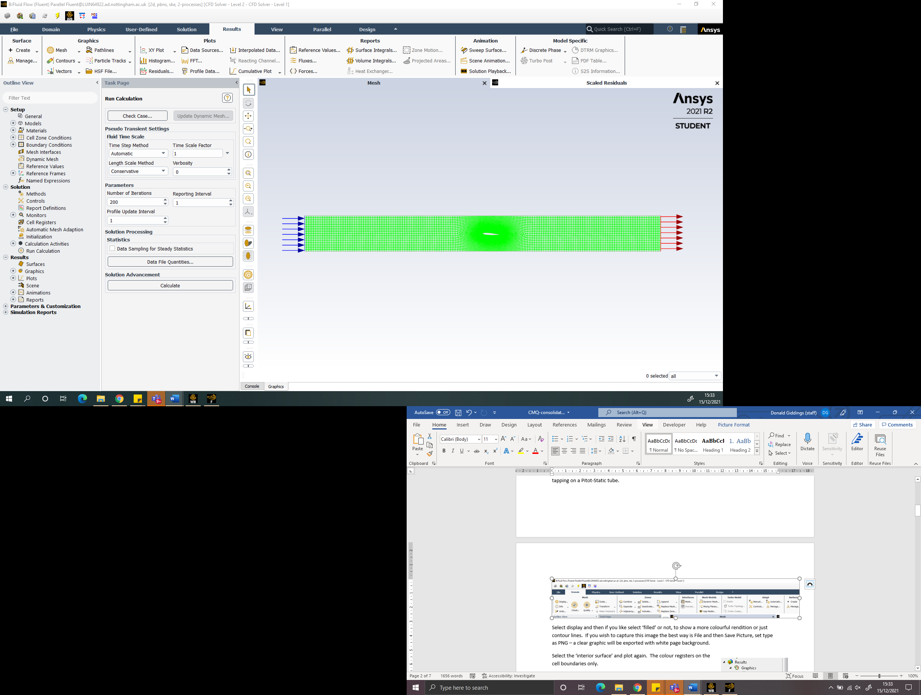

Figure (top) menu showing ‘Results’ selected where the various graphics options can be selected, (left) contours panel for plotting data on contours, (right) Mesh Display panel for showing the mesh or the geometry on contour plots and other graphic plots.

Select display and then if you like select ‘filled’ or not, to show a more colourful rendition or just contour lines.

Side note: although contradictory to the method of finite volume which requires nodes at cell centres, this is because Fluent uses the word ‘node’ for the cell face intersection points (i.e. on the faces of the cells), and the term ‘cell-centre’ for the central point of the cell (i.e. what we call the node in the theory) and it is only to do with terminology use.

Select the ‘interior surface’ and plot again. The colour registers on the cell boundaries only.

Plot the total pressure underneath the ‘Contours of’ on the drop down menu (this registers the velocity based dynamic pressure due to velocity variation) as indicated by a Pitot dynamic pressure tapping.

There are several variables that can be selected under pressure and velocity and turbulence.

Selecting ‘Node Values’ should make the contours plot values stored at nodes in each cell – giving uninterpolated cell values and a blocky appearance. There appears to be a minor error in the code (since this option is not used often) in that not selecting node values appears to provide the node values, and selecting node values causes interpolated values to be plotted.

Selecting ‘Auto Range’ causes the colour bar to range across the whole scale of values in the solution. Without auto range you can limit the range of values to a range of interest – values outside the range selected won’t be plotted. Selecting ‘Clip to Range’ with Auto Range makes the values greater than that highest selected all at the highest indicated colour, and those lower than the lowest, all at the lowest colour. For example see what pattern happens when you look at only negative static pressure. You can press Compute at the bottom of the Contours panel if you forget the range.

# Step 3: Printing graphics neatly

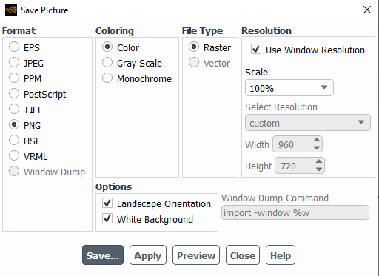

Figure Save Picture panel accessed from the File drop down menu, for saving images in a more controlled way, without the background colour seen in the graphics console and with colour or ‘Gray Scale’.

If you wish to capture the image from the contour plot, the best way is File and then Save Picture (Figure 3), set type as PNG – a clear graphic will be exported with a plain page background if you select ‘White Background’.

# Step 4: 2D velocity vector plot

Select Vectors, New, and display velocity vectors similarly (Figure 4). The ‘color by’ option allows selection of an alternative variable to colour the variables, e.g. you may want the velocity vectors to be coloured by static pressure, or you may want to colour by velocity in x-direction. Usually just leaving as velocity is best.

Changing the Scale of the velocity vectors plotted can help to make the image clearer. Skip can be useful if you have a very dense mesh.

The selection of auto range is as for contours. Plotting the mesh, as for contours, will show aspects of the geometry like inlets and other surfaces and may be used to show the cells associated with the velocity vectors observed. The Vector Options allows fixed length vectors to be plotted, but be wary of the Scale in that case, for this project change the scale to 0.005 to produce 5 mm long vectors, and remember to change the scale back again if you deactivate Fixed Length vectors. Style can be used to change the type of vector shown, see if you like the others, but I think the default ‘3d arrow’ is best.

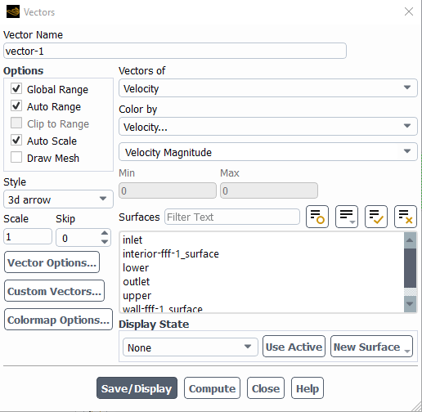

Figure 4 Velocity vector panel with options to ‘Color by’ other flow variables. Usually colouring by velocity magnitude is best. Also available are setting the Draw Mesh to plot the geometry outline, or to show the mesh with the vectors if desired. And the Auto Scale on or off allowing a particular range of velocity to be shown only to isolate areas of interest.

# Step 5: Reporting

In the overhead menu select Results and then Reports and Fluxes (Figure 2, top). Select Mass Flow Rate and select inlet and outlet and compute; you should see very little imbalance of mass flux if the case is converged in the solution part of the project. But it would show if there is a difference between the mass going in and that leaving.

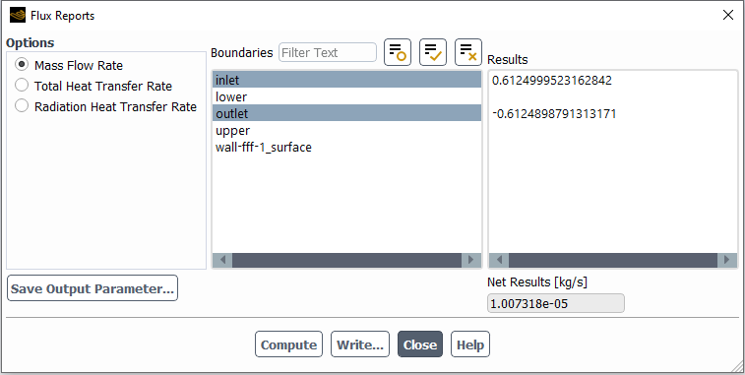

Figure 5 Flux Reports, and Mass Flow Rate selected on the inlet and outlet boundary conditions showing the mass flow rate into and out of the domain according to the numerical calculation. Note the very small discrepancy between the ingoing air and that leaving, showing that the case is well solved based on continuity.

Bear in mind this is a 2D model and that mass fluxes are calculated volumetrically, so it assumes a 1m depth. You should check this makes sense by the usual ṁ = ρAU, where A is the cross section area, height of inlet multiplied by 1 m length.

Without energy equation solving, there will be no heat transfer or radiative heat transfer to calculate the flux of, but could be useful for future models.

# Step 6: how to get surface forces report (for working out the drag and lift forces)

Select Reports from the overhead Results menu and Forces (Figure 7, top). Select the upper and lower surfaces of the aerofoil in the Wall Zones panel, and select the direction you are interested in, X for drag and Y for lift in my case, and Print. Go to the Console (remember the tabs underneath the display window), and you will see the data for the force on the surfaces (Figure 7, bottom).

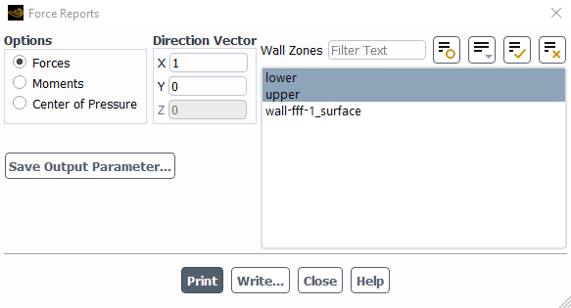

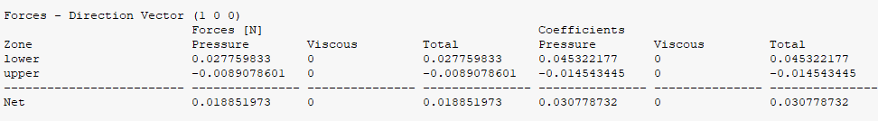

Figure 6 (top) Force Reports panel showing Forces selected, in the X direction vector and on the lower and upper surfaces of the aerofoil as defined in the mesh named edges in part 1. (bottom) dialogue on the Console after Print on the Force Report.

# Step 7: rakes – important for coursework

On Results (overhead menu) and Surface (left side), select ‘Create’ and choose ‘Line/Rake’. Select chosen coordinates for the rake. A rake defines a line of equally distanced data points, and is an inherited name from wind tunnel measurements where Pitot tubes or hot wire anemometers would be held in a line something like a garden rake, creating a regular and fixed measuring array of velocity.

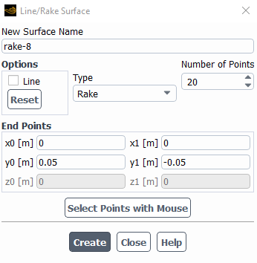

Figure 7 Line/Rake create panel

Select the points for the beginning and end of the line defining the rake. The geometry (0,0) point is the nose of the aerofoil, so put a rake across there. x0 = 0, y0 = 0.05, x1 = 0, y1 = -0.05 and number of points, say 40 for now, to define the number of measurement points. Give it a name, or leave as default if you prefer, then Create the rake. You can plot velocity vectors on that rake if you open the velocity vectors panel. The alternative here is Line, which puts a line between the coordinates which registers a measurement at every cell position along the line.

In Surface and Manage on the postprocessing tab, you can delete any lines that you create in error or realise you don’t want anymore.

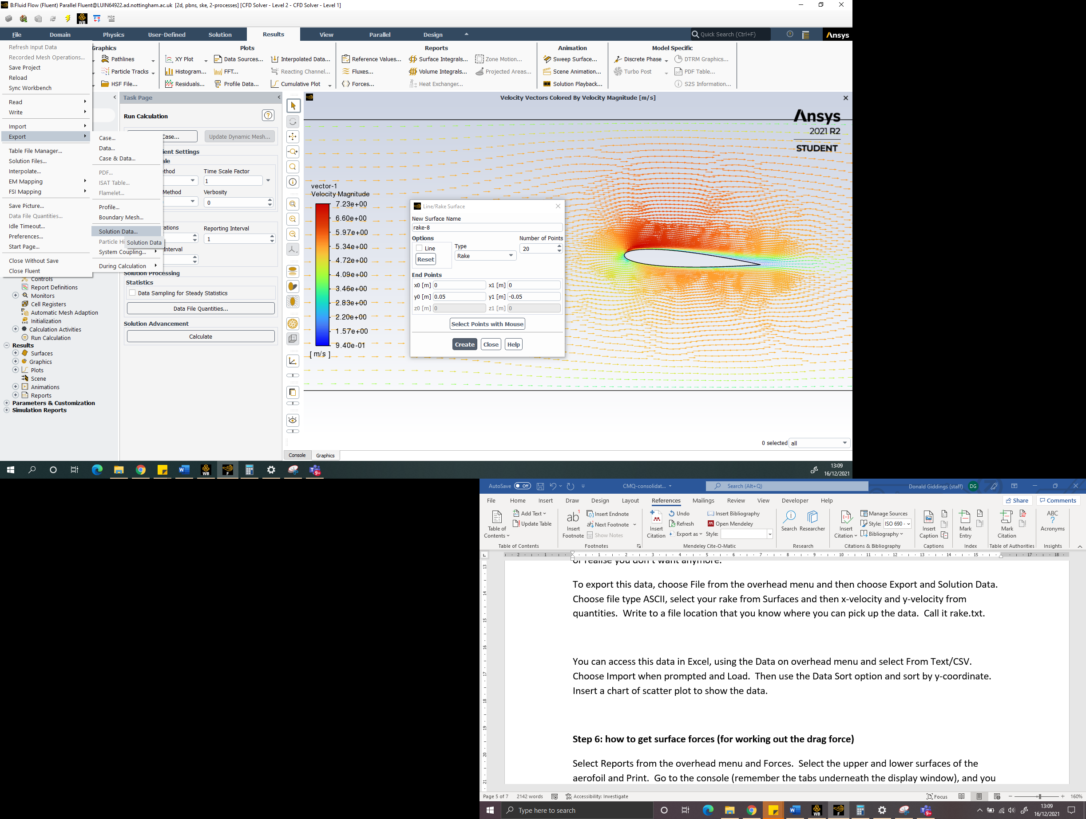

Figure 8 File menu dropdown list showing Export and the further list showing Solution Data for export.

To export this data, choose File from the overhead menu and then choose Export and Solution Data (Figure 6). Choose file type ASCII, select your rake from Surfaces and then x-velocity and y-velocity from quantities. Write to a file location that you know where you can pick up the data. Call it rake.txt.

You can access this data in Excel, using the Data on overhead menu and select From Text/CSV. Choose Import when prompted and Load. Then use the Data Sort option and sort by y-coordinate. Insert a chart of scatter plot to show the data (Figure 6). Remember to change the file type it’s looking for to All Files (*.*) so it will show the file regardless of the filetype showing on it.

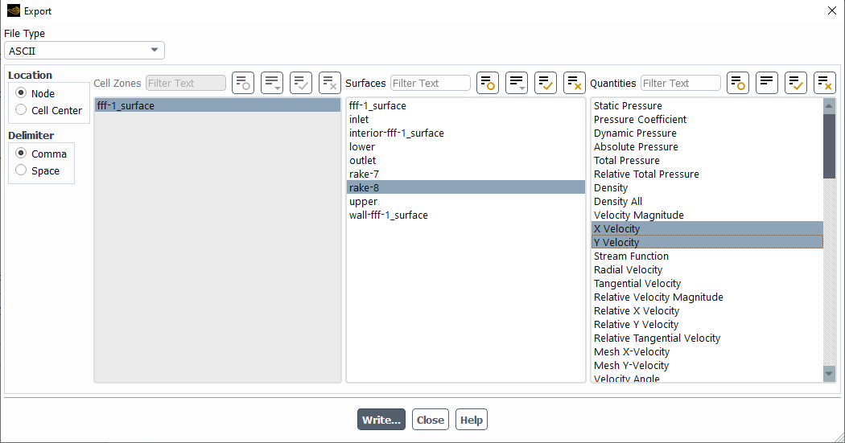

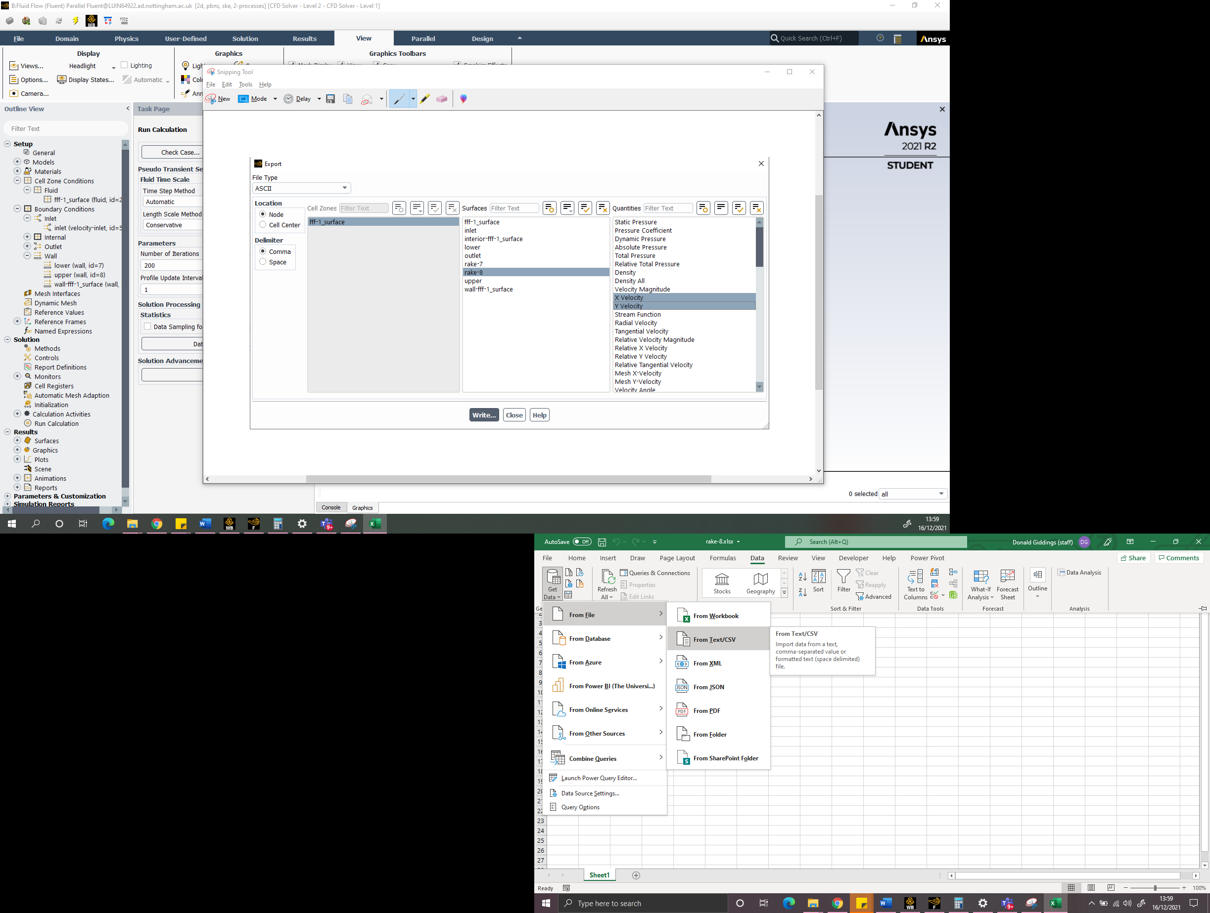

Figure 9 (top) File menu, Export, Solution Data brings up this panel. Select ASCII from the drop down list, and selected rake-8 in this case with X-Velocity and Y-Velocity to export on it. (bottom) Excel Data, Get Data drop down list showing From File and From Text/CSV (comma separated variable).

# The following sections are for information only, and may be useful for those developing their own Fluent models.

# Step 8: defining planes on 3D models (not necessary for coursework)

Open the project with the 3D model with completed solution for 0.05m/s inlet boundary velocity condition and pressure outlet 0 Pa gauge pressure.

On postprocessing and surface select create, but this time go for Plane to create a virtual surface on which to plot vectors or contours.

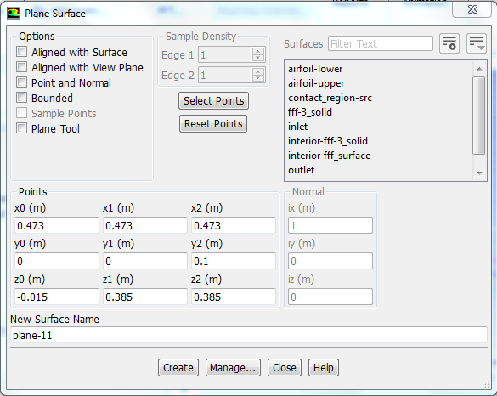

Figure 10 Plane Surface panel, with coordinates of the points defining a plane in a 3D model.

Do this in two ways:

1. Use ‘Select Points’ and use the mouse probe to define 3 corner points on the outer surface of the model which define the plane – right click on the top centre towards the bend end, then on the top centre at the other end, and finally, on the lower surface in the centre at the outlet end, using the mouse left button tools to turn the model to get access to the appropriate parts.
2. OR you can do it using coordinates – check the scale of the model (in setting up domain tab) to identify the max and min x, y, and z of the model. Identify the centre plane location – in this case y=0.05m, and then put in the following coordinates into the create plane tool, in which you can coordinates of the centreline plane are placed in randomly selected x and z coordinates to define the plane orientation:

|  |  |  |
| --- | --- | --- |
| x | y | Z |
| 0 | 0.05 | 0 |
| 0 | 0.05 | 0.1 |
| 0.1 | 0.05 | 0.1 |

1. Then ‘create’ the named plane in the new surface name box. Go to vector plot or contour plot and select the plane – you should see vectors or contours plotted.

The first option is for when you just want an approximate view, and the second is if you require an accurate location.

# Step 9: creating isosurfaces – not important for coursework

This is for displaying surfaces of constant value of a flow variable, e.g. constant velocity or pressure.

Postprocessing tab, Surface and Create – choose Isosurface. Select Surface of Constant pull down menu and select velocity magnitude. Press compute and the max and min range will appear. Use the slide bar to select a value in the range – create the plane with a name. Then choose another and another velocity, as many as you want.

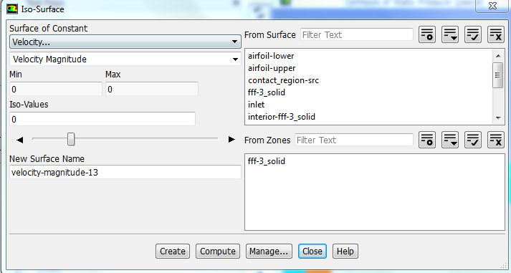

Figure 11 Iso-Surface panel for defining surfaces of constant value flow variables, e.g. pressure, density, temperature, for more complicated models and illustration.

# Step 10: displaying iso-surfaces – not important for coursework

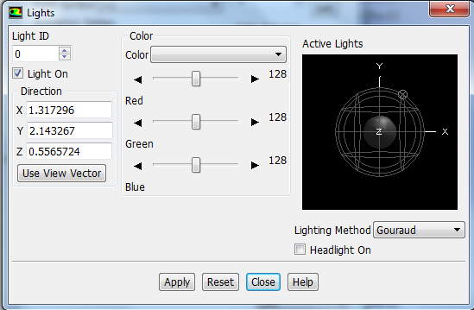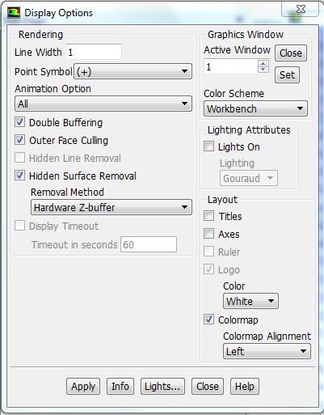

Figure 12 Display options panel (left) and Lights panel (right) for adjusting the appearance and rendering of graphics.

To display, select contour plot, and select colour by velocity magnitude on the isosurfaces just created. You will just see the outer surface – which isn’t altogether useful, so remove the outer faces. Go to Viewing tab (shown above on the mouse probe setting section), and select Options on the left. Select Outer Face Culling to remove the nearest faces in the view. Again the view is not all that useful because although you can see inside, it has no depth of vision due to now shading. So add some lighting to the scene. Click the Lighting in Viewing Options. Depth is added. The lights can be altered using the Options tab – use view vector is quite useful to give head on lighting.